


Module Code & Module Title
CS6P05NP Project

Assessment Type
Proposal

Student Name: Sanjog Gurung
London Met ID: 23048924
College ID: NP04CP4A230050
Assignment Due Date: 14th November, 2025
Assignment Submission Date: 14th November, 2025
Submitted To: Mr. Sandeep Gurung
I confirm that I understand my coursework needs to be submitted online via My Second Teacher under the relevant module page before the deadline in order for my assignment to be accepted and marked. I am fully aware that late submissions will be treated as non-submission and a mark of zero will be awarded.
Table of Contents
Chapter 1: Introduction 1
1.1 Introduction of the Project 1
1.2 Problem Domain 1
1.3 Project as a Solution 2
• Professional Online Presence: 2
• Easy Access to Trainer Information: 3
• Automated Booking System: 3
• Transparent Pricing and Membership Options: 3
• Improved User Engagement: 3
• Centralized Platform for Fitness Guidance: 3
1.4 Aims and Objective 3
1.5 Tools and Resources Required 4
1.5.1 Frontend Tools 5
1.5.2 Backend Tools 7
1.5.3 Database Tools 7
1.5.4 Design Tools 8
Chapter 2: Literature Review/ Background 8
2.1 Elaboration of Chapter 1 8
2.2 Journal Articles 9
2.1.1 ASGBOOKSYS: All Star Gym Booking System with Usability Heuristic Theory Adaptation 9
2.1.2 Computerized System to Manage Business Functionalities for a Gymnasium 9
2.1.3 Design of a Web-Based Membership Data Processing System at Vizta Gym using the Prototype Method 10
2.1.4 Development of Web‑Based Information System to Support Personal Trainers' Performance in Medan 10
2.3 Similar Projects 10
2.3.1 Development of a Web-Based Gym Information System at Nahaga Sabu Seba 10
2.3.2 Design and Implementation of Web-based Gym Management System 11
2.3.3 Designing a Web-Based Membership Data Processing System at Vizta Gym by the Prototype Method 11
2.3.4 Computerized System to Manage Business Functionalities for a Gymnasium 12
2.3.5 MERN Architecture-based Full-Stack Gym Management System for Fitness Centres 12
2.4 Comparison with Similar Projects 12
2.4.1 System Objective 12
2.4.2 Technology Stack 13
2.4.3 Design and User Interface 13
2.4.4 Feature integration 13
2.4.5 Scope and Flexibility 13
2.4.6 Data Security and Management 14
2.4.7 User Engagement 14
Chapter 3: Methodology 15
3.1 Software Development Methodology 15
3.1.1 Waterfall Model 15
3.1.2 Spiral Model 16
3.1.3 Incremental Model 16
3.1.4 Agile Methodology 17
3.2 Reasoning of the Incremental Approach for Shadow Fit 17
Chapter 4: Expected Outcome 19
4.1 Functional Deliverables 19
4.1.1 Web-Based Gym Platform 19
4.1.2 Trainer and Membership Management 19
4.1.3 Booking and Scheduling System 19
4.1.4 Interactive User Features 20
4.1.5 Database and Backend Components 20
4.2 Documentation Deliverables 20
Chapter 5: Work Breakdown Structure 21
5.1 Work Breakdown Structure of the Project 21
5.2 Description of Work Approach 22
Chapter 6: Milestones Listing 23
5.1 Project Milestones 23
6.2 Description of Work 24
Chapter 7: Gantt Chart 24
References 26

Table of Figure
Figure 1: HTML Logo 5
Figure 2: CSS Logo 5
Figure 3: JavaScript Logo 6
Figure 4: Bootstrap Logo 6
Figure 5: Django Logo 7
Figure 6: MySQL Logo 7
Figure 7: Waterfall Model Diagram 15
Figure 8: Spiral Model Diagram 16
Figure 9: Incremental Model Diagram 16
Figure 10: Agile Methodology Diagram 17
Figure 11: Work Breakdown Structure 22
Figure 12: Gantt Chart 25

Table of Tables
Table 1: Milestones List Table 24

Chapter 1: Introduction

Introduction of the Project
Web-based services have been on the rise over the past few years for different industries, including health and fitness services. People now expect to access information, compare options, and make bookings online. Despite this, many small and medium-sized gyms rely heavily on traditional systems, manual registration like paper records or scheduling appointments by phone. This may be very time consuming and prone to errors, hence inconvenient for both clients and gym staff.
Shadow Fit is a web-based gym management and trainer booking system. It seeks to provide a digital platform through which one can effortlessly navigate services offered in the gym, trainers' profiles, training schedules, membership plans, and book training sessions. The system will also support secure login for users and an admin dashboard that will allow the gym administrator to manage trainers, schedules, and bookings.
The system will be developed using the Django framework for backend development and HTML, CSS, JavaScript, and Bootstrap for the frontend. Django will be used because it supports rapid development and has built-in features like authentication and database handling. On the other hand, Bootstrap is chosen to support responsive and user-friendly web page layouts.

Problem Domain
Many gyms have operational problems because an effective digital management system is lacking. Among others, the common issues are:
- Most of the small and medium-level gymnasiums still use traditional methods of phone calls, word of mouth, and paper records for membership and training scheduling purposes. These often lead to misunderstandings, inefficiencies, and errors in scheduling.
- Customers often have problems accessing current information concerning trainers, pricing plans, and other services offered at the gym. Without a focal point that electronically keeps this information, users will often find themselves making uninformed choices.
- A lack of transparency in membership levels, costs of personal training, and service packages could discourage prospective clients from joining or continuing their patronage of the facility, as unclear pricing diminishes trust and motivation.
- Lack of online booking and scheduling systems means that customers must make session reservations manually; this increases the chances of double booking, lost reservations, and customer dissatisfaction.
- Modern customers are increasingly looking to digital accessibility in their search for services. It will be difficult for gyms that are not online to attract new members, especially those in younger and more tech-savvy demographics.
- With the fitness industry showing an increasing demand for personalized and trainer-guided workout experiences, users should have access to the profiles and expertise of the trainers before choosing training programs.
- Without a digital platform integrating information about trainers, schedules, booking, and membership plans, gyms struggle to engage their members, organize operations, or manage their services.

Project as a Solution
The Gym Website project offers a practical solution to the issues and challenges that exist within the local gyms and their customers. The project has come up with a solution that offers customers access to the services that the gyms offer in an organized and attractive manner through the use of a digital platform. The customers are also in a position to book sessions with the gyms through the website.
The project responds to these challenges in the following ways:

Professional Online Presence:
The website provides the gym with an online presence that potential customers are able to browse before visiting the establishment.

Easy Access to Trainer Information:
Offering comprehensive profiles about the trainers’ specialties and rates ensures that users are well-informed about who to train with.

Automated Booking System:
The users can check the schedules that are available and book training sessions right from the website without the need to manually call and book sessions.

Transparent Pricing and Membership Options:
Every service package and membership option is prominently displayed on the website to eliminate ambiguities and build user trust.

Improved User Engagement:
The inclusion of features such as interactive timelines, health calculators, blogs, and galleries keeps visitors to the website engaged.

Centralized Platform for Fitness Guidance:
Tubes The user can get all the information, trainer advice and gym services in one platform without depending on other scattered resources.
In this way, the website provides benefits to the fitness club by offering solutions to its problems while improving the user experience to increase membership acquisition and retention.

Aims and Objective
The main aim of this project is to create a professional and user-interactive website that helps users to easily understand the gym's services, explore available trainers, check schedules, choose membership plans and directly book training sessions online. This project aims at making communication between the gym and its customers smoother with reduced manual work on both ends, while providing the user with the convenience of staying in touch with the gym any time.

The objective of the project:
- Create a user-friendly, responsive website interface that works perfectly on any device.
- To give full and clear profiles of personal trainers, including their specialties, experience, and pricing.
- To display the schedule of classes and timing of training sessions in a comprehensible, yet organized, manner.
- To enable users to create accounts, log in, and book training sessions or classes directly through the website.
- To showcase membership plans and pricing in a clear, easily comparable manner.
- Store and manage user data, trainer details, schedules, and booking information securely through a reliable database.
- To include a contact form and location details in order to make communication between the gym and users easier.
- To create an engaging website layout with appealing visuals that improves user experience and encourages user interaction.
- The purpose is to lessen manual workload for gym personnel by automating tasks like registration, booking, and management of schedules.
- Improved overall accessibility so that users can obtain necessary information about the gym at any time and from anywhere.

Tools and Resources Required
Developing a comprehensive and dynamic gym website requires a combination of frontend, backend, database, and design tools and resources. Each tool and resource plays a specific role in ensuring the website is functional, responsive, and user-friendly. The required tools and resources are described below:

Frontend Tools

HTML (Hypertext Markup Language):

Figure 1: HTML Logo
HTML provides the fundamental structure of all web pages, organizing content such as headings, paragraphs, tables, images, links, and forms. It is used to structure the gym website pages including homepage, trainer profiles, schedules, and booking forms. HTML is essential for creating semantic and accessible web pages, improving both usability and search engine optimization (Robbins, 2018).

CSS (Cascading Style Sheets):

Figure 2: CSS Logo
CSS styles the website including layout, colours, fonts, spacing, and responsive behaviour. It's used to ensure that the gym website is visually appealing and consistent across devices. CSS allows separation of content from presentation, enhancing maintainability and user experience (Meyer & Weyl, 2017).

JavaScript:

Figure 3: JavaScript Logo
JavaScript adds interactivity to web pages including dynamic schedules, form validation, interactive elements, and animations. It helps to enable features such as filtering training schedules, validating booking forms and dynamically updating content without page reloads. JavaScript improves user engagement and supports real-time interaction which are critical for modern web applications (Flanagan, 2020).

Bootstrap:

Figure 4: Bootstrap Logo
Bootstrap provides prebuilt responsive layouts, UI components, and design utilities. The project uses it to ensure the website is mobile-friendly and consistent across different screen sizes with minimal coding effort. Frameworks like Bootstrap reduce development time and maintain design consistency across projects (Spurlock, 2013).

Backend Tools

Django (Python Web Framework):

Figure 5: Django Logo
Django handles all the server-side logic, database interaction, user authentication, routing and template rendering of the project. It helps to power dynamic content such as user accounts, booking systems, trainer management, and schedule updates in the project. Django uses a Model-View-Template (MVT) architecture that separates concerns and enhances maintainability in web applications (Lathkar, 2025).

Database Tools

MySQL (Relational Database Management System):

Figure 6: MySQL Logo
MySQL is used to store structured data such as user profiles, trainer information, schedules, bookings, and membership plans acting as the central repository for all persistent data ensuring data integrity, security and efficient querying. Relational databases are widely used for web applications due to their robustness and support for complex queries (Date, 2019).

Django ORM (Object-Relational Mapping):
It provides a Python-based interface to interact with the database without writing raw SQL queries simplifying CRUD (Create, Read, Update, Delete) operations for trainers, users, schedules, and bookings. ORMs increase developer productivity and reduce the likelihood of SQL errors while maintaining data integrity (Gorodnichev, et al., 2020)

Design Tools

Figma / Canva:
These tools are used for wireframing, prototyping, and visual mock-ups of the website, helping to plan page layouts, navigation flow, and visual design before actual coding. These are prototyping tools that enhances collaboration between designers and developers and reduce design errors (Tidwell, 2019).

Chapter 2: Literature Review/ Background

Elaboration of Chapter 1
In Chapter 1, there was an introduction to the project for Shadow Fit, a website that will offer a digital platform to gyms and their users. Several small and medium-sized gyms use manual methods for membership and scheduling through paper records or over the phone.
It solves these problems by offering an online system in which users can view gym services, trainer profiles, schedules, membership plans, and book training sessions. It also allows administrators of the gym to manage trainers, schedules, and bookings efficiently through a secure dashboard.
The backend of the website will be designed using Django, incorporating secure login, database management, and dynamic content. The frontend will involve the use of HTML, CSS, JavaScript, and Bootstrap to ensure a responsive, interactive, and user-friendly website. In general, the system helps gym operations run more smoothly and provides users with easy access to online services in the gym.

Journal Articles
Various scholarly works were considered in a review to understand how web-based gym management systems work. These explained how online booking, membership management, and trainer information systems help gyms to work more smoothly. It also showed the problems gyms face when using manual methods and how these could be improved through digital solutions. Following are some articles of importance for the Shadow Fit project:

ASGBOOKSYS: All Star Gym Booking System with Usability Heuristic Theory Adaptation
This study describes the development of an online booking system that replaces manual appointment arrangements in a Malaysian gym. The authors used the Waterfall development model and assessed usability by means of Heuristic Theory, reaching an average usability rating of 4.57 out of 5. The work underlines that making the process of creating a booking easy and free of errors for the user significantly enhances the latter's experience. The relevance to your project is direct: one of your key features is a booking system, and this article shows what has been done and what user expectations are regarding usability (Ibrahim, et al., 2024).

Computerized System to Manage Business Functionalities for a Gymnasium
The authors present in the paper a system built for a gymnasium that automates core business operations: trainer management, membership tracking, scheduling, and payments. The paper argues that manual methods lead to inefficiencies and error‑prone operations, and the computerized system improves reliability, data integrity, and operational speed. This supports your "problem domain" section where you identify that many gyms still use manual systems (Gamage, et al., 2022).

Design of a Web-Based Membership Data Processing System at Vizta Gym using the Prototype Method
This article focuses specifically on membership data and problems when multiple gym branches have inconsistent manual verification. The authors developed a web‑based system through the prototype approach, which addresses issues of member verification, schedule information, and active memberships. It improves accessibility, speed, and accuracy. These features align with your project: membership plans, registration, and schedule display (Sembiring, et al., 2023).

Development of Web‑Based Information System to Support Personal Trainers' Performance in Medan
This article targets the trainer-side of gym operations. It reports on a web-based information system for personal trainers to log clients' training programs, body composition data, and progress tracking. It reveals that the overall feasibility stands at 94.75% and underlines how the digital system enhanced the efficiency of trainers, coupled with data-driven service. For your project, this directly relates to the features "trainer profile" and "schedules + booking", in that your system provides access for users to data about trainers, while trainers have tools for managing their work (Tarigan, et al., 2025).

Similar Projects
To better situate this project within what has already been done, this section presents several web-based gym/fitness management systems. These projects show how other developers approached booking, membership, trainer management, and online accessibility that the same problems our Shadow Fit system addresses:

Development of a Web-Based Gym Information System at Nahaga Sabu Seba
The research describes how the gym changed from manual record-keeping to a completely web-based system that manages members, payment handling, and operations. The Agile development method is used and key features include membership registration, selection of membership packages, digital payment, downloading membership cards, and an administrative dashboard in real-time. It was designed to give remote access and to improve service quality. The kind of feature set directly matches the feature of the project to plan-member registration, payment, and dashboard for admins-along with the benefits of moving from manual to digital (Alboneh & Snae, 2025).

Design and Implementation of Web-based Gym Management System
This project was undertaken in China, focusing on the design of the gym management system that would cover daily business operations both for the gym and its end-users. It employs the B/S architecture, adopting JSP technology as the front-end and MySQL database for backend storage. The system aims to deal with all kinds of data and information generated in daily gym business. It shows architecture and technical stack choices for web-based gym systems and gives insight into how to structure our own system in terms of backend, frontend, and database (Zhao, et al., 2023).

Designing a Web-Based Membership Data Processing System at Vizta Gym by the Prototype Method
This article presents a fitness centre that has memberships across branches using manual verification and thus suffers from scheduling/verification problems. The authors designed a web-based system via prototype method and UML modelling, which improved the processing of data on the administrator side and also helped members to view schedules and transactions online. It aligns closely with the focus on membership plans, membership verification, and schedule visibility features that is included in Shadow Fit (Sembiring, et al., 2023).

Computerized System to Manage Business Functionalities for a Gymnasium
This work describes a computerized system that manages trainers, memberships, scheduling, payments, and other business functionalities of a gym. The authors have pointed out that the paper/phone-based manual systems are inefficient and prone to errors. They also show evidence that a digital system enhances reliability and speed. It supports Shadow Fit project's problem domain of gyms using manual methods and hence the need for automation and web-based management (Gamage, et al., 2022).

MERN Architecture-based Full-Stack Gym Management System for Fitness Centres
This article describes a full-stack system built using MongoDB, Express.js, React.js, and Node.js. It automates membership management, workout planning and progress tracking in fitness centres. The system addresses limitations imposed by paper or spreadsheet-based methods, showing one of the modern tech stacks for gym management. It provides a relevant example of a modern web tech stack for systems dealing with fitness/gym systems. This can inform design decisions and is good to get an idea of present trends (Hasan, et al., 2025).

Comparison with Similar Projects
The review of previous projects on gym management reveals that most of the existing systems automate the basic functions of a gym: membership, trainer management, and dealing with financial activities. Shadow Fit will upgrade that by offering an interaction-based, more visually attractive, and user-friendly platform. Important comparisons are highlighted below:

System Objective
- Most of the projects so far have focused on automating existing manual systems for registration, membership, and scheduling onto an online platform.
- Shadow Fit does not only focus on automating these processes but also enhancing user engagement, transparency, and accessibility.
- It includes additional features like blogs, health calculators, and communication tools that would help in motivating people and keeping them well-informed.

Technology Stack
- Other systems used technologies like JSP + MySQL (Zhao, et al., 2023) and MERN stack (Hasan, et al., 2025).
- Backend operations are powered by Django (Python) while using HTML, CSS, JavaScript, and Bootstrap for the frontend.
- Django has an inbuilt authentication system, better security, and faster development compared to other frameworks.

Design and User Interface
- For instance, previous projects like Vizta Gym System (Sembiring, et al., 2023) have focused mainly on functionality, with less attention to design.
- Shadow Fit focuses on responsive, attractive, and mobile-friendly design created using Bootstrap and Figma/Canva.
- It ensures consistency in the user experience across all devices.

Feature integration
- Most previous systems covered only basic modules, such as membership management and trainer scheduling.
- Shadow Fit puts everything in one place: trainer profiles, membership plans, schedules, bookings, and contact forms.
- It allows users to interact with trainers for instant booking, thus enhancing usability.

Scope and Flexibility
- Previous projects were primarily one-off designs for a single gym and lacked scalability.
- Shadow Fit is designed with a modular architecture, enabling its easy extension for multiple branches or the addition of new features, such as payment systems and progress tracking.
- Its architecture supports long-term adaptability and growth.

Data Security and Management
- Some older projects lacked proper data protection and relied on manual data storage.
- Shadow Fit uses Django's authentication system and MySQL database for secure data storage and encryption.
- Ensuring user data privacy and system reliability also applies here.

User Engagement
- Older systems were primarily transaction-based with less user interaction.
- Shadow Fit inspires interaction through the utilization of blogs, photo galleries, and health tools, among others.
- This keeps users connected and increases member retention for the gym.
- Shadow Fit synthesizes the strengths of prior projects and improves on their weaknesses.
It focuses on design quality, user interaction, transparency, and scalability. Hence, the project not only effectively manages gym operations but does so through a more modern, secure, and responsive platform for greater user satisfaction and engagement.

Chapter 3: Methodology

Software Development Methodology
A software development methodology is a structured approach to developing, maintaining, and delivering software. It defines which activities are involved in the development process, the roles of different team members, the tools to be used, and what deliverables are produced at each stage (Ibrahim, et al., 2018). A good methodology makes sure that the software is developed in an efficient manner to meet users' requirements; it should also be able to accommodate scope or technological changes (Conceição, et al., 2023). The proper selection of methodology is relevant for time, resource, and risk management, as well as quality management for such complex projects as web-based systems (Serebryantseva & , 2023).
The selection of an appropriate methodology in this project will serve to organize the development of Shadow Fit-a website for managing gyms and booking trainers-such that features like membership management, trainer profiles, schedules, and booking can be implemented in such a systematic way that they are reliably delivered. The following are a number of popular software development methodologies, each with various strengths, weaknesses and applicability with respect to project type, size, and requirements:

Waterfall Model
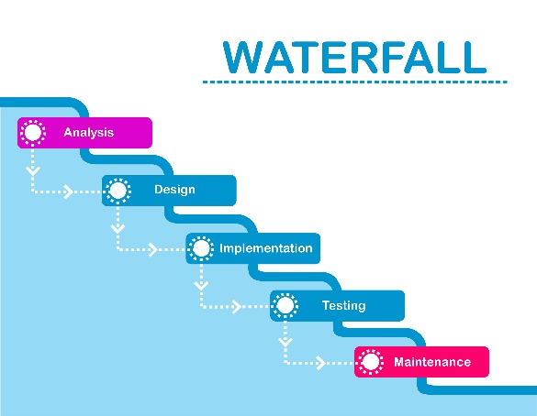
Figure 7: Waterfall Model Diagram
Waterfall is a linear, successive model where a phase starts once the previous one has been completed, such as; requirements, design, implementation, testing, deployment and maintenance. In this methodology, clear milestones are provided, documented and the progress is easily traceable. Whereas, accommodating changes is difficult and it has problems that only show up towards the end of the development. Its best use is when the requirements are clearly defined and unlikely to change (Pressman & Maxim, 2021).

Spiral Model
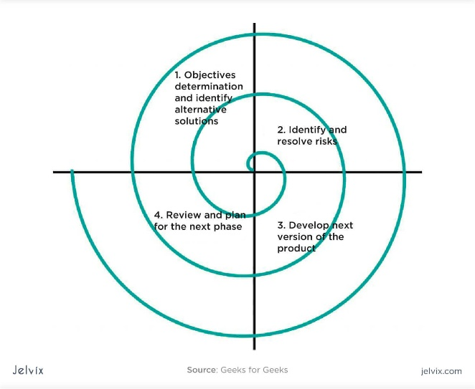
Figure 8: Spiral Model Diagram
The Spiral model is iterative and risk-driven and consists of repeated cycles of planning, risk analysis, development, and evaluation. It is good for large, high-risk projects and permits frequent reassessment of requirements. Whereas, it can be complex and expensive, requires experienced team members for risk assessment. It best applies to projects having high uncertainty or critical risk factors (Boehm & Turner, 2019).

Incremental Model
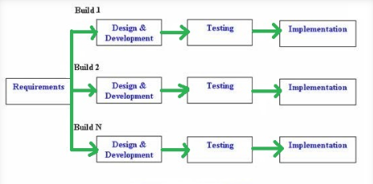
Figure 9: Incremental Model Diagram
In the Incremental model, the software system is built in small, functional pieces called increments. Rather than developing the entire system at once, each increment adds a part of the system’s functionality as it builds in stages. It provides working software early thus; it allows the users to test features. Can accommodate requirement changes during the development. Early problem discovery which reduces risk. It requires careful planning and integration management. This is more adaptable to projects where the features can be delivered step by step (Conceição, et al., 2023).

Agile Methodology
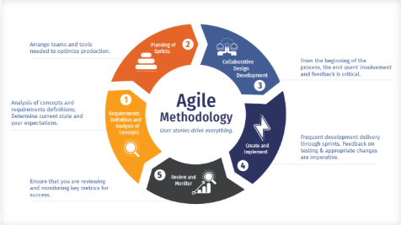
Figure 10: Agile Methodology Diagram
Agile focuses on flexibility, collaboration, and customer feedback. Methods include Scrum, Kanban, and Extreme Programming (XP). Agile projects work in short iterative sprints, delivering small increments frequently. It is highly flexible, encourages frequent user feedback, faster delivery. However, it requires less formal documentation and strong team coordination. It is best suitable for the projects with rapidly changing requirements and active user involvement (Kotaiah & Khalil, 2024).

Reasoning of the Incremental Approach for Shadow Fit
Incremental methodology has been chosen for the Shadow Fit project. The reason being:
- Feature-Based Delivery: Shadow Fit has a number of key features that will be implemented: trainer profiles, booking system, membership plans, schedules, admin dashboard. The incremental delivery means the product is released in parts, so some functionality is delivered early while building other features.
- Requirement Flexibility: The user's requirements will probably get changed on the way. The incremental development allows features to be changed or enhanced based on early feedback, which a waterfall approach keeps rigid.
- Risk Management: Early delivery of small pieces enables the detection of technical or integration problems before the entire system is ever finished.
- User Experience: Early working versions mean that gym staff and clients can try the system, providing feedback on how to improve its usability and overall satisfaction.
- Time and Resource Management: In a final year project, the resources and time are not sufficient therefore, incremental methodology allows focused development in phases with the assurance that each portion is complete and functional.
Software development methodology represents a structured approach to how a software is built, tested, and maintained. Within the major models discussed, incremental methodology was chosen for Shadow Fit because of its flexibility, phased delivery, integration of user feedback, reduction of risk, and resource efficiency. The implementation of the project will be incremental, with each increment delivering workable features to the continuous testing and improvement of the product.

Chapter 4: Expected Outcome
The expected outcomes of the Shadow Fit project define tangible and functional results to be delivered by means of the project. The focus of these outcomes is on delivering a complete, user-friendly, and interactive web-based platform for gym management and trainer bookings with the purpose of enhancing the overall experience for the gym's clients and staff, while at the same time reducing manual work and enhancing operational efficiency.

Functional Deliverables
The project is expected to produce the following key functional components:

Web-Based Gym Platform
- A website accessible on desktops, tablets, and mobile devices, is responsive and interactive.
- The website shall include, among others, an About page, Services Offered, Trainer Profiles, Class Schedules, Membership Plans, and finally, ways to book.
- It will eventually act as the digital entity for the gym, bringing in new customers and maintaining the current members.

Trainer and Membership Management
- A secure login system where gym administrators can manage trainers, membership plans, schedules, and bookings.
- The profiles for personal trainers will highlight their specialties, experience, certification, and pricing for the services offered.
- Membership plans will be clearly displayed for users to choose the most suitable package.

Booking and Scheduling System
- Users will be able to view available training sessions and make an appointment on their own through the website.
- The system will automate scheduling, therefore eliminate double bookings and reduce human errors.
- Bookings will be easy to manage for both users and administrators.

Interactive User Features
- Incorporating tools that engage the user, such as a BMI calculator, a workout tracker, and a diet planner.
- Blog and gallery sections displaying workout advice, success stories, and motivational content.
- Contact forms and maps for convenient communication and directions to the gym location.

Database and Backend Components
- MySQL relational database using Django ORM to persist data: user accounts, trainers' information, membership, and all the records of bookings.
- Secure storage and management of data to maintain privacy and information integrity.
- The backend logic involves supporting dynamic content through automated processes while ensuring smooth interactions between users and administrators.

Documentation Deliverables
Besides the functional system, the project will provide complete documentation to support end-users and administrators along with future developers:
- User Manual: A clear, step-by-step guide of how users can create their accounts, book sessions, go through trainer profiles, interact, and so on.
- Administrator Guide: Step-by-step guidance on how to manage the trainers, schedules, memberships, and bookings effectively.
- Technical Documentation: Full system architecture explanation, database schema, back-end logic, and code structure for maintenance, upgrade, and troubleshooting purposes.
The Shadow Fit project will provide a complete web-based gym management system, incorporating trainer management, membership plans, scheduling, and booking into one platform. Besides that, it will be supported by detailed documentation for users, staff of the gyms, and developers. This project will improve operational efficiency, enhance the user experience, reduce manual work, and provide a professional, reliable, and interactive platform for managing gym services.

Chapter 5: Work Breakdown Structure
A WBS is the most critical project management tool which breaks down the whole project into minor, manageable sections to make the planning and execution systematic and organized. It gives a clear perspective that defines the work to be done, the sequence of doing it, and who will do it. WBS is a hierarchical decomposition of project scope, whereby the identification of deliverables takes place and the team efforts are organized. It forms the basis for scheduling, budgeting, and monitoring progress (Kerzner, 2022).
A WBS is necessary in software development projects for structuring tasks from the initial requirement phase down to final deployment. In addition, it ensures that every step of development, such as analysis, design, implementation, testing, and documentation, is well planned and executed sequentially. It allows for effective communications among the developers and stakeholders, enabling individual tracking of each activity until its completion (PMI, 2021).

Work Breakdown Structure of the Project
The WBS for the Shadow Fit, gym management system is developed using an Incremental Software Development Methodology. This type of methodology breaks down the project into multiple increments or pieces and can be stated that each increment adds specific features to the system. An example could be that the first increment will incorporate the homepage and trainer profiles, the second increment will include membership and booking systems, while in later increments, admin and schedule management modules will be included. In this model, each stage produces an operational version of the software. It allows early testing and feedback that may be incorporated into improving the final product.
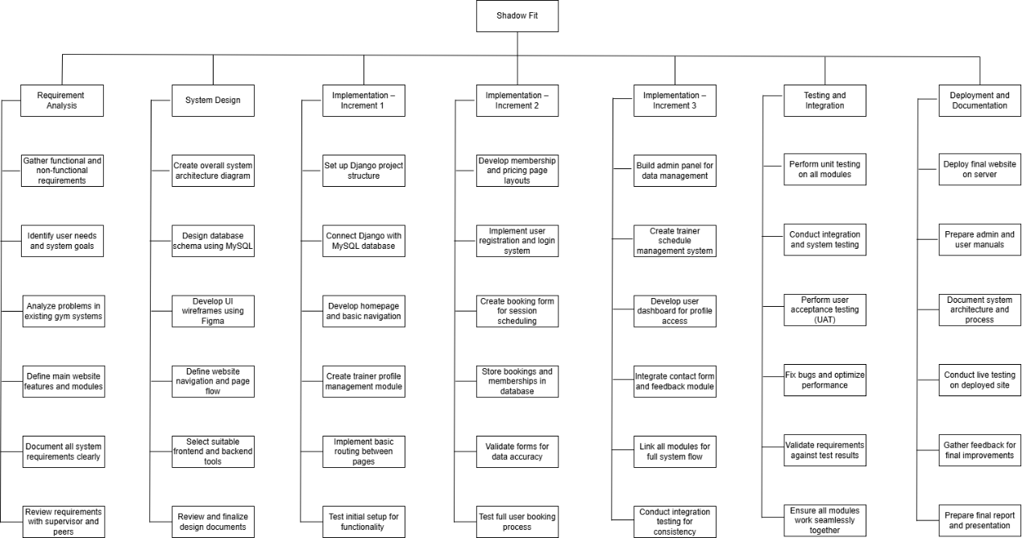
Figure 11: Work Breakdown Structure

Description of Work Approach
The Shadow Fit project is being developed according to the Incremental Software Development Model, in which the work is divided into smaller stages that are more manageable. Each stage, or increment, focuses on implementing a set of related features.
First, the foundation is established in the first increment by setting up the environment in Django, designing the homepage, and creating trainer profiles. The second increment includes developing and testing the membership and booking systems. The third increment covers the construction of the admin dashboard and the trainer scheduling module.
Testing is done after every increment to identify and fix errors early. This is a step-by-step process to ensure that the system will be stable and functioning throughout development. The incremental approach also allows for user feedback continuously to improve usability and performance before the final deployment. WBS will ensure that the development activities are defined, there is timely completion, and there will be no budget or scope deviations. In this way, it provides a clear roadmap from initial planning to final delivery, ensuring successful completion of Shadow Fit Gym Management Website with proper documentation of results.

Chapter 6: Milestones Listing
A project milestone is a major point or event in a project that marks the completion of a major activity or phase. The milestones help in tracking progress, managing time, and ensuring that the project remains right on schedule. They also help the team verify if the project is on course to meet its objectives (Kerzner, 2022).
Generally, in software projects, the milestones are set for key stages: planning, requirement analysis, system design, development, testing, deployment, and documentation. Having clear milestones helps to organize the work better, ensuring progress towards meeting the objectives of the project (PMI, 2021).
For the Shadow Fit Gym Management System, milestones are planned in a way that applies to the Incremental Software Development Methodology, meaning the project is divided into smaller parts and each milestone represents the completion of one part or major feature. This approach allows features to be tested and improved step by step.

Project Milestones
No. | Milestone | Description
1 | Project Planning | Definition of project scope, objectives, tools and methodology.
2 | Requirement Analysis | Gather functional and non-functional requirements and prepare SRS.
3 | System Design | Design system architecture, database schema, and UI/UX wireframes.
4 | Increment Development – 1 | Develop homepage, trainer profile module, and basic navigation.
5 | Increment Development – 2 | Implement membership plans, booking system, and user authentication.
6 | Increment Development - 3 | Admin dashboard, trainer scheduling module, and feedback system development.
7 | Testing & Integration | Conduct unit, integration, system, and user acceptance testing.
8 | Deployment | Deploy website on server, make sure all modules work.
9 | Documentation | Prepare user manual, admin guide and technical documentation.
10 | Final Review & Submission | Review project deliverables, submit report and present project.
Table 1: Milestones List Table

Description of Work
The Shadow Fit Gym Management System is developed following the Incremental Software Development approach, splitting the entire work into manageable milestones. Each milestone encompasses the development of the project features step by step. Planning and requirement analysis, system design comprising architecture, database, and UI wireframes, are the initial steps of the project. Then, the implementation is done incrementally: first, the homepage and trainer profiles, followed by membership and booking features; and lastly, the admin dashboard and scheduling modules. Each increment is tested and integrated before proceeding to the next. The final milestones include deployment, documentation, and a review of the project. This ensures feedback early on, orderly development, and the delivery of functional modules reliably. This incremental milestone-based approach enables the completion of the project step by step, allows for early detection of errors, includes feedback, and makes sure each part of the system is working effectively before moving on to the next stage.

Chapter 7: Gantt Chart
A Gantt chart is a project-planning tool that displays project tasks on a timeline using horizontal bars. It shows when each task begins, how long it will take, and when it should be completed. This helps in organizing work, understanding task sequences, and tracking progress throughout the project. Gantt charts are widely used in software development because they make scheduling and monitoring activities clearer and more efficient (Larson & Gray, 2021).
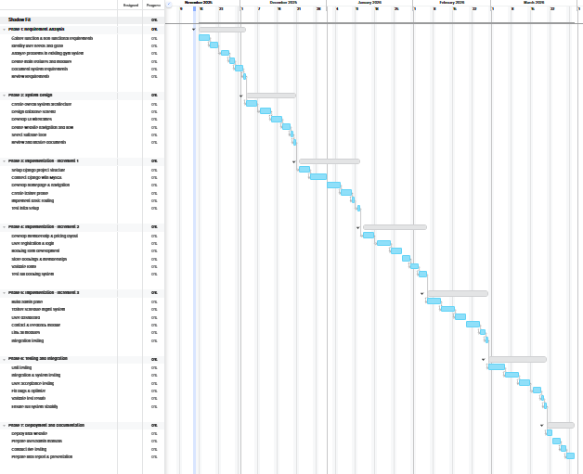
Figure 12: Gantt Chart
The Gantt chart for the Shadow Fit project outlines all the major activities, from requirement analysis to deployment, in a planned timeline ranging from mid-November to late March. In addition, each task is placed in its appropriate dependencies, such as Finish-to-Start and Start-to-Start, to illustrate how the continuity from one activity leads to another. Since the project involves an Incremental methodology, the chart further divides the development work into three increments that add essential features of the system in steps. Furthermore, it excludes Saturdays to make the academic schedule realistic. This Gantt chart will ensure that the project proceeds in a properly organized, controlled, and timely manner.

References
Alboneh, A. F. A. & Snae, M., 2025. Development of a Web-Based Gym Information System at Nahaga Sabu Seba. Journal of Artificial Intelligence and Engineering Applications, 3(1907-1914), p. 4.
Boehm, B. & Turner, R., 2019. Balancing Agility and Discipline: A Guide for the Perplexed. 2nd ed. Boston: Addison-Wesley Professional.
Conceição, L., Carr, C. R. N., Silva, D. d. & Margarido, C., 2023. The incremental model in software development: a structured and interactive way to deliver quality products. Research, Society and Development, Volume 4, p. 12.
Date, C. J., 2019. Database Design and Relational Theory: Normal Forms and All That Jazz. 2nd ed. Database Design and Relational Theory: Normal Forms and All That Jazz: Apress.
Flanagan, D., 2020. JavaScript: The Definitive Guide. 7th ed. Sebastopol, California: O’Reilly Media.
Gamage, T. C. M. et al., 2022. Computerized System to Manage Business Functionalities for a Gymnasium. International Journal of Engineering and Management Research, 5(73-81), p. 12.
Gorodnichev, M. et al., 2020. Exploring object-relational mapping (ORM) systems and how to effectively program a data access model. PalArch’s Journal of Archaeology of Egypt/Egyptology, 3(615-627), p. 17.
Hasan, P. & H., 2025. A Full-Stack Gym Management System for Fitness Centers Using MERN Architecture. International Journal of Scientific Research in Science, Engineering and Technology, 5(70-75), p. 12.
Ibrahim, N., Fauzee, F. A., Sa’dan, S. A. & Mohd Bahrin, U. F., 2024. ASGBOOKSYS: All Star Gym Booking System with Usability Heuristic Theory Adaptation. Journal of Information Systems Research and Practice, 3(76–96), p. 2.
Ibrahim, Z., Johar, M. G. M. & Rahman, N. R. A., 2018. An Efficiency and Effectively of Methodology in Software Development Workflow Based on Malaysia. International Journal of Engineering and Technology, 4.28(526-536), p. 7.
Kerzner, H., 2022. Project Management: A Systems Approach to Planning, Scheduling, and Controlling. 13th ed. Hoboken: Wiley.
Kotaiah, B. & Khalil, M. A., 2024. Approaches for development of Software Projects: Agile methodology. International Journal of Advanced Research in Computer Science (IJARCS).
Larson, E. W. & Gray, C. F., 2021. Project Management: The Managerial Process. 8th ed. New York: Project Management: The Managerial Process.
Lathkar, M., 2025. Modern Django Web Development: With Channels, DRF, GraphQL, and React. 1st ed. New York: Apress.
Meyer, E. A. & Weyl, E., 2017. CSS: The Definitive Guide: Visual Presentation for the Web. 4th ed. Sebastopol, California: O’Reilly Media.
PMI, 2021. A Guide to the Project Management Body of Knowledge (PMBOK® Guide) – 7th Edition. 7th ed. Newtown Square: PMI Publishing.
Pressman, R. S. & Maxim, B. R., 2021. Software Engineering: A Practitioner’s Approach. 9th ed. New York: McGraw-Hill Education.
Robbins, J. N., 2018. Learning Web Design: A Beginner's Guide to HTML, CSS, JavaScript, and Web Graphics. 5th ed. Sebastopol, California: O’Reilly Media.
Sembiring, R., Situmorang, D. & Simbolon, A., 2023. Design Of A Web-Based Membership Data Processing System At Vizta Gym Using A Prototype Method. International Journal of Engineering and Computer Science, 2(25-32), p. 10.
Serebryantseva, E. & e. a., 2023. Structured software development versus agile software development: a comparative analysis. International Journal of System Assurance Engineering and Management, 14(1504-1522).
Spurlock, J., 2013. Bootstrap: Responsive Web Development. 1st ed. Sebastopol, California: O’Reilly Media.
Tarigan, H., Akhmad, R. & Tantri, E., 2025. Development of Web-Based Information System to Support Personal Trainers’ Performance in Medan. Journal of Education and Health Research, 1(45-54), p. 12.
Tidwell, J., 2019. Designing Interfaces: Patterns for Effective Interaction Design. 3rd ed. Sebastopol, California: O’Reilly Media.
Zhao, D., Wang, F. & Zhu, X.-f., 2023. Design and Implementation of Gym Management System Based on Web. Nanchang, Atlantis Press.

